**Build and Run Java API from NetBeans**

**­­­­­­­­­­­_________________________**

**Introduction:**

This document describes how to build Java API and run sample application from Netbeans.

# **Instructions to build JAVA API**

1. Download netbeans IDE for respective OS platform(windows/mac/Linux).
2. After downloading, install the software by following the steps mentioned in the following link:

[*https://netbeans.org/community/releases/80/install.html*](https://netbeans.org/community/releases/80/install.html)

1. Download the Mercury API SDK from [*https://www.jadaktech.com/documentation/rfid/mercuryapi/*](https://www.jadaktech.com/documentation/rfid/mercuryapi/) and extract it.
2. Open the project “*samples_nb*” in Netbeans IDE by choosing File=>Open Project and then selecting the project files(you will find “*mercuryapi_nb*” and “*samples_nb*” projects at path “*SDK\java*”).
3. Build the *samples_nb* project by right clicking on the project and select “*Build*” option.

**Note**: Instructions to find out serial port connected**:** Open Device manager and check for the serial port number (which is connected to the host machine and to the reader) under “Ports” section.

# **Instructions to run sample codelet**

After successful build, run the sample codelet by following the steps mentioned in below figure:

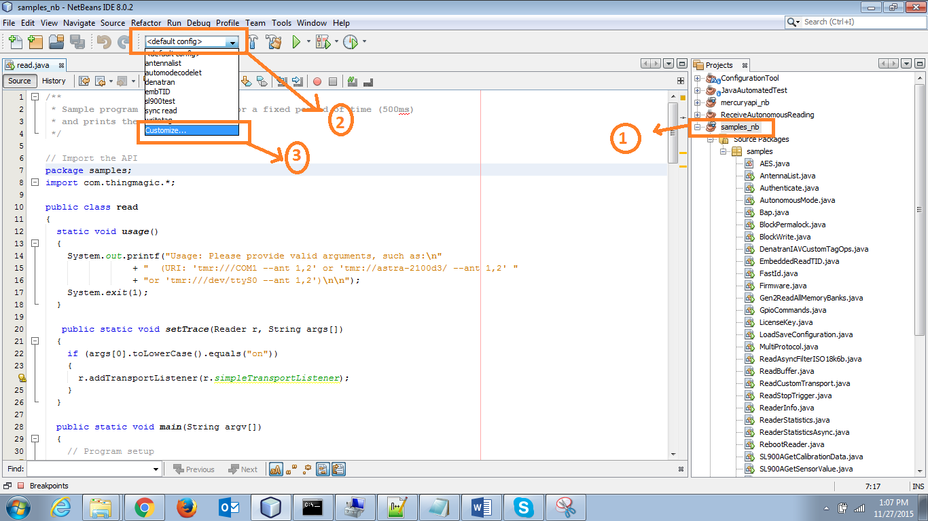

A sample_nb Project Properties window appears as shown below. Please provide URI based on the usage provided in the codelet.

*For example*: To run the read sample codelet, provide the arguments like “*tmr:///com21 --ant 1*” or “*tmr://<ip address> --ant 1,2”* in the Arguments section as shown in below figure and click on run button at the top.

